[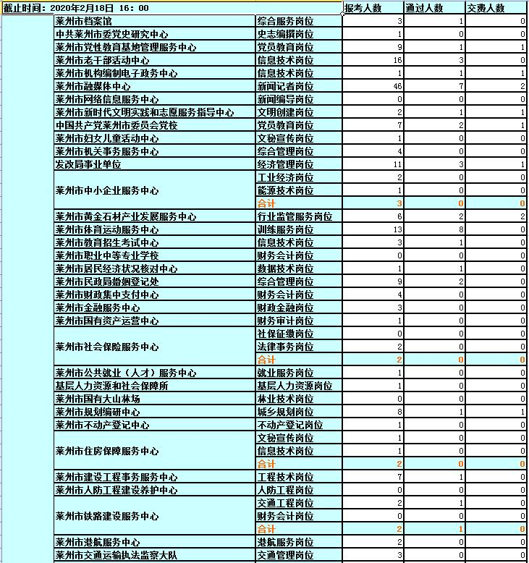](http://www.laizhou.gov.cn/picture/0/ef5de6f4fc18460696eadd67c671bbea.jpg)

[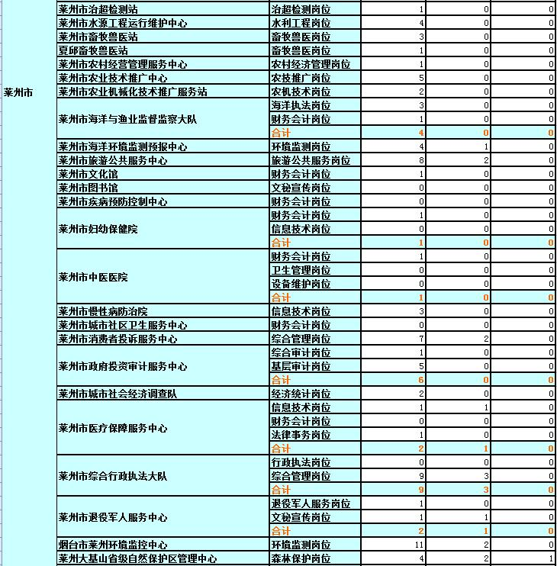](http://www.laizhou.gov.cn/picture/0/d64f6a5175a045b68e133c2f5cab0c62.jpg)

[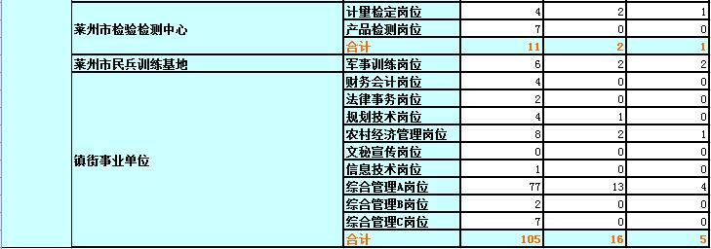](http://www.laizhou.gov.cn/picture/0/0713c358cf2249a0bbbd9bd4a411e955.jpg)